**MCT-238L Embedded Systems I (ES-I)**

**Semester Project (CEP)**

**Submitted To:**

**Mr. Shujat Ali**

**Submitted By: (Group # 2)**

**Zohaib Ayaz (2021-MC-02)**

**Muhammad Anees (2021-MC-03)**

**Muawwiz Ali Yousuf (2021-MC-13)**

**Hajra Qureshi (2021-MC-33)**

**Kinza Fatima (2021-MC-34)**

**Date:** 23rd May 2023

________________________________________________________________

**Department of Mechatronics & Control Engineering**

**UNIVERSITY OF ENGINEERING & TECHNOLOGY LAHORE**

**Contents**

Project Description 3

Key Parameters for AMBU Bag Ventilation 3

Project Outcomes 3

Description of Components 4

Bread Board Interfacing 6

Pinout Connections 7

Hardware Connections 9

Complete Project 10

Working Project GIF 11

Bill of Materials 12

AMBUlator

# Project Description

For severely ill patients who have significant respiratory distress or failure, mechanical ventilation is a life-supporting procedure. In several circumstances, patients may need to be ventilated, including while they are undergoing surgery and under general anesthesia. One is mechanical ventilation to save human life, particularly for unconscious patients. A National Library of Medicine paper states that lower-middle-income nations like Pakistan lack essential life-saving supplies, particularly ventilators and qualified personnel.

Patients who are unable to breathe on their own are frequently given life-saving oxygen in the interim using AMBU Bag-based mechanical ventilation. By pressing the AMBU bag to supply oxygen to the patient's lungs, qualified medical workers can manually ventilate patients using this portable equipment. The AMBU bag is also a useful option for emergency oxygenation in many contexts because of its low cost and wide availability.

Due to the shortage of skilled paramedic staff, mechanical ventilation is frequently provided by untrained professionals, such as a patient's close relative. Given that the patient's life is on the line. By creating and managing an intelligent device that can squeeze an AMBU bag, we can automate this manual process. We call this system an AMBUlator.

# Key Parameters for AMBU Bag Ventilation

* **Tidal Volume** is the volume of air that is delivered to the patient's lungs with each breath. It is usually measured in milliliters (mL) or cubic centimeters (cc).
* **Respiratory Rate (RR)** is the number of breaths delivered by the ventilator per minute. It is usually expressed as breaths per minute (BPM).
* **Inspiration/Expiration Ratio (I: E)** refers to the duration of the inspiratory phase of each breath compared to the duration of the expiratory phase. It is usually expressed as a ratio, such as 1:2 or 1:3.

# Project Outcomes

The control of critical ventilation parameters is important according to patient needs. We are providing Human Machine Interface (HMI) to Doctors and Paramedic staff for setting these critical parameters, such as:

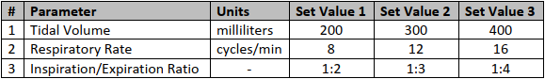

# Description of Components

A wide variety of components are used in this project. The description of these components is given below:

* 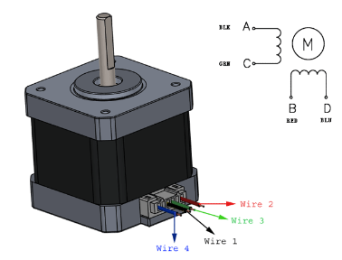**Stepper Motor (NEMA 23):**

NEMA 23 is a high torque hybrid bipolar stepper motor with a 2.3×2.3-inch faceplate. This motor has a step angle of 1.8 deg., which means that it has 200 steps per revolution and for every step, it will cover 1.8°. The motor has four color-coded wires (Black, Green, Red & Blue) terminated with bare leads. Black and Green wire relates to one coil; Red and Blue relate to the other.

NEMA 23 motor can be made to rotate only if the coils are energized in a logical sequence. This logical sequence can be programmed using a microcontroller or by designing a digital circuit.

* 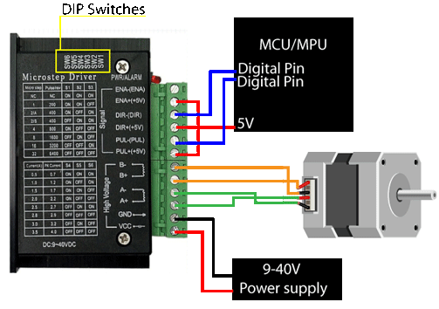**TB6600 (Motor Driver):**

TB6600 Stepper Motor Driver Controller 4A is an easy-to-use professional stepper motor driver, which can control a two-phase stepper motor. It is compatible with microcontrollers that can output a 3-5V digital pulse signal. Jumper wires are used to connect the stepper motor to the Microcontroller.

TB600 has an operating voltage of 9-40V. Its pulse input frequency is 20kHz. It can provide an output current from 0.7-4.0A. It is the most suitable driver for 2-phase motors.

* 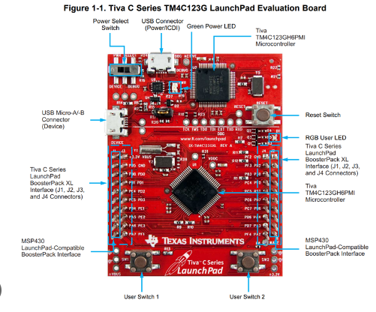**TM4C123GH6PM (Micro Controller):**

The microcontroller used in this project is the TIVA C series TM4C123GH6PM. The TM4C123GH6PM microcontroller is targeted for industrial applications, including remote monitoring, electronic point-of-sale machines, test and measurement equipment, network appliances and switches, factory automation, HVAC and building control, gaming equipment, motion control, and transportation. It is one of the most suitable microcontrollers for this project.

* **LCD Display:**

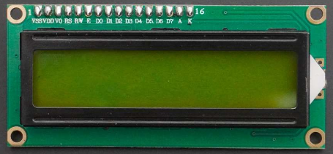Liquid Crystal Display (LCD) is an electronic device, which is frequently used in many applications for displaying information in a text or image format. The LCD is used for displaying the alphanumeric character on its screen. The LCD consists of 8-data lines and 3-control lines which are used for interfacing the LCD with the microcontroller.

* 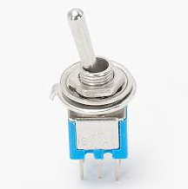**Toggle Switches:**

Toggle switches are best used for changing the state of system functionalities. A toggle switch is designed to provide a path for current to flow through, either turning on or turning off (breaking or making a circuit). Toggle switches are operated by hand, usually, a small lever flicked up or down.

In this project nine (9) toggle switches are used to make 27 conditions to control parameters like Inhalation and Exhalation (I: E) ratio, Tidal Volume, and Breaths Per Minute (BPM).

* 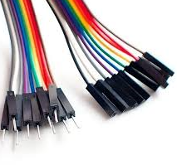**Jumper Wires:**

A jumper wire is an electric wire that connects remote electric circuits used for printed circuit boards. By attaching a jumper wire to the circuit, it can be short-circuited and short-cut (jump) to the electric circuit. Jumper wires are typically used with breadboards and other prototyping tools to make it easy to change a circuit as needed.

* **Potentiometer:**

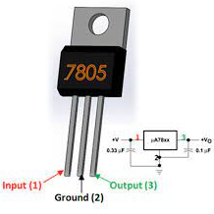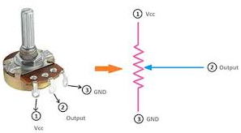A potentiometer is a three-terminal electrical device used to measure and control an electric current. It measures the potential difference between two of its terminals, usually in steps or fractions of a volt. Potentiometers work by varying the position of a sliding contact across a uniform resistance. In a potentiometer, the entire input voltage is applied across the whole length of the resistor, and the output voltage is the voltage drop between the fixed and sliding contact. In this project, the potentiometer is used to control the color contrast of the LCD.

* **Voltage Regulator (LM7805):**

LM7805 is used to regulate the voltage provided by the power supply to 5V. A heat sink can be used through the GND terminal to protect the IC from high currents or short circuits. In this project, LM7805 is used to provide 5 volts to LCD.

* 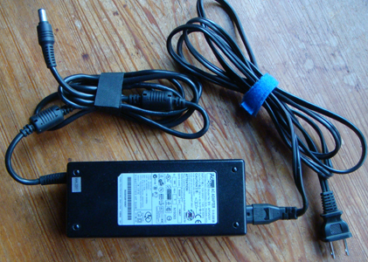**Power Supply:**

A power supply is an electrical device that offers electric power to an electrical load such as a laptop computer, server, or other electronic devices. The main function of a power supply is to convert electric current from a source to the correct voltage, current to power the load. In this project, power is supplied to the components through a 12V power supply.

* 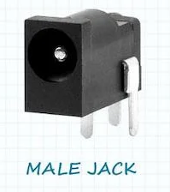**Connectors:**

Connectors are used to join subsections of circuits together. Usually, a connector is used where it may be desirable to disconnect the subsections at some future time: power inputs, peripheral connections, or boards which may need to be replaced.

* **Printed Circuit Board (PCB):**

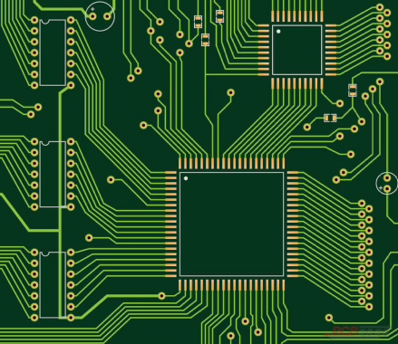A printed circuit board, or PCB, is used to mechanically support and electrically connect electronic components using conductive pathways, tracks, or signal traces etched from copper sheets laminated onto a non-conductive substrate. Electronic components are mounted on the board and the traces connect the components to form a working circuit or assembly.

# Bread Board Interfacing

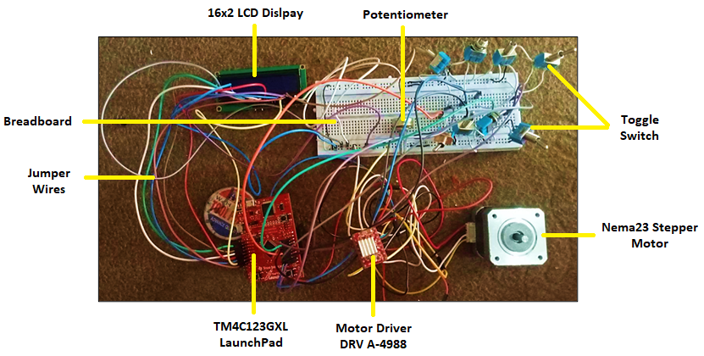

# Pinout Connections

**Stepper Motor**

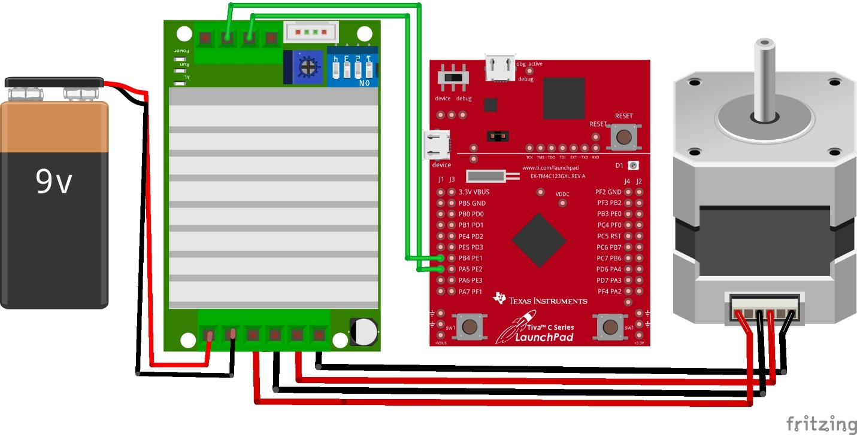

**LCD**

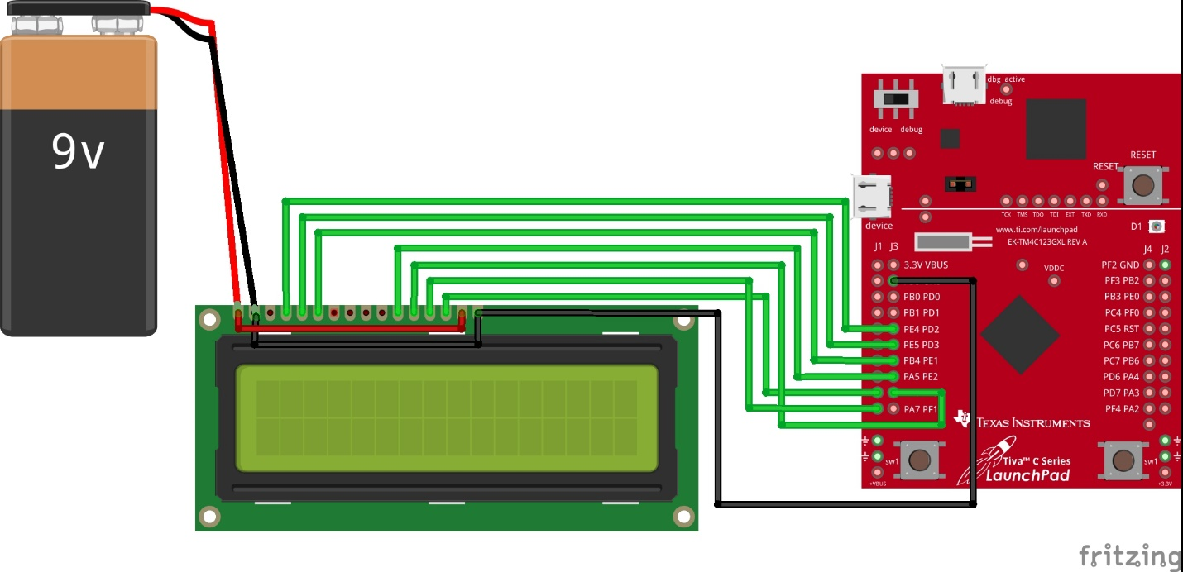

**Toggle Switches**

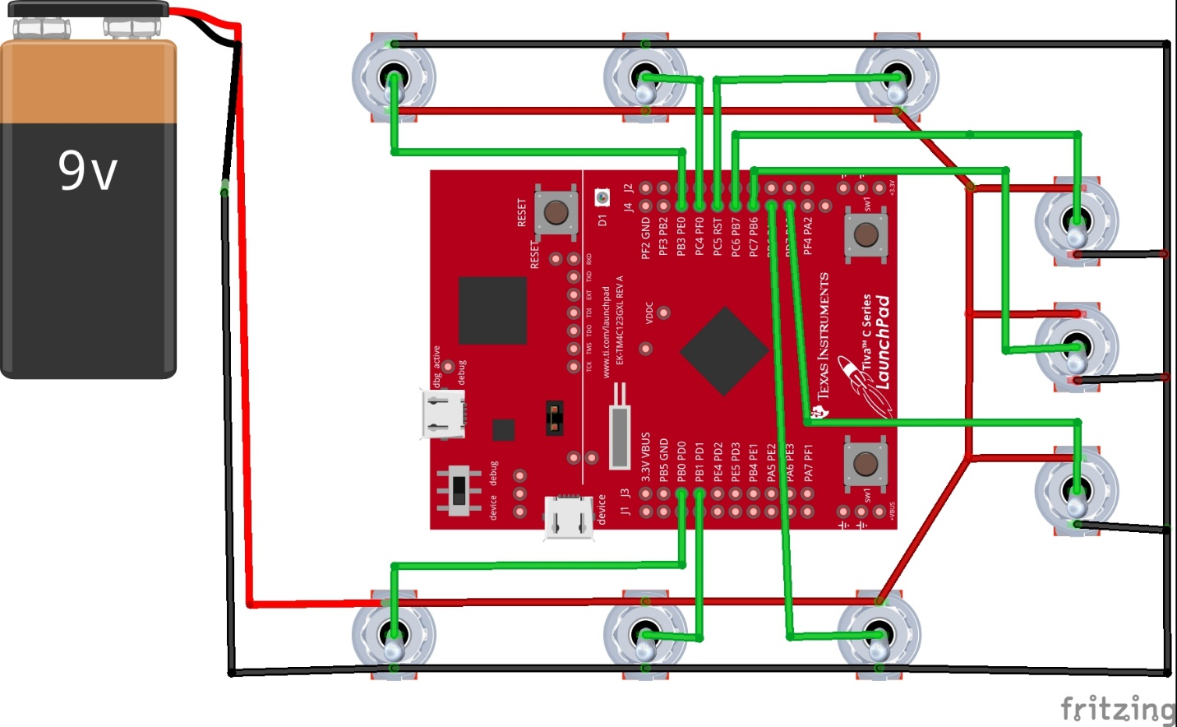

# Hardware Connections

**LCD**

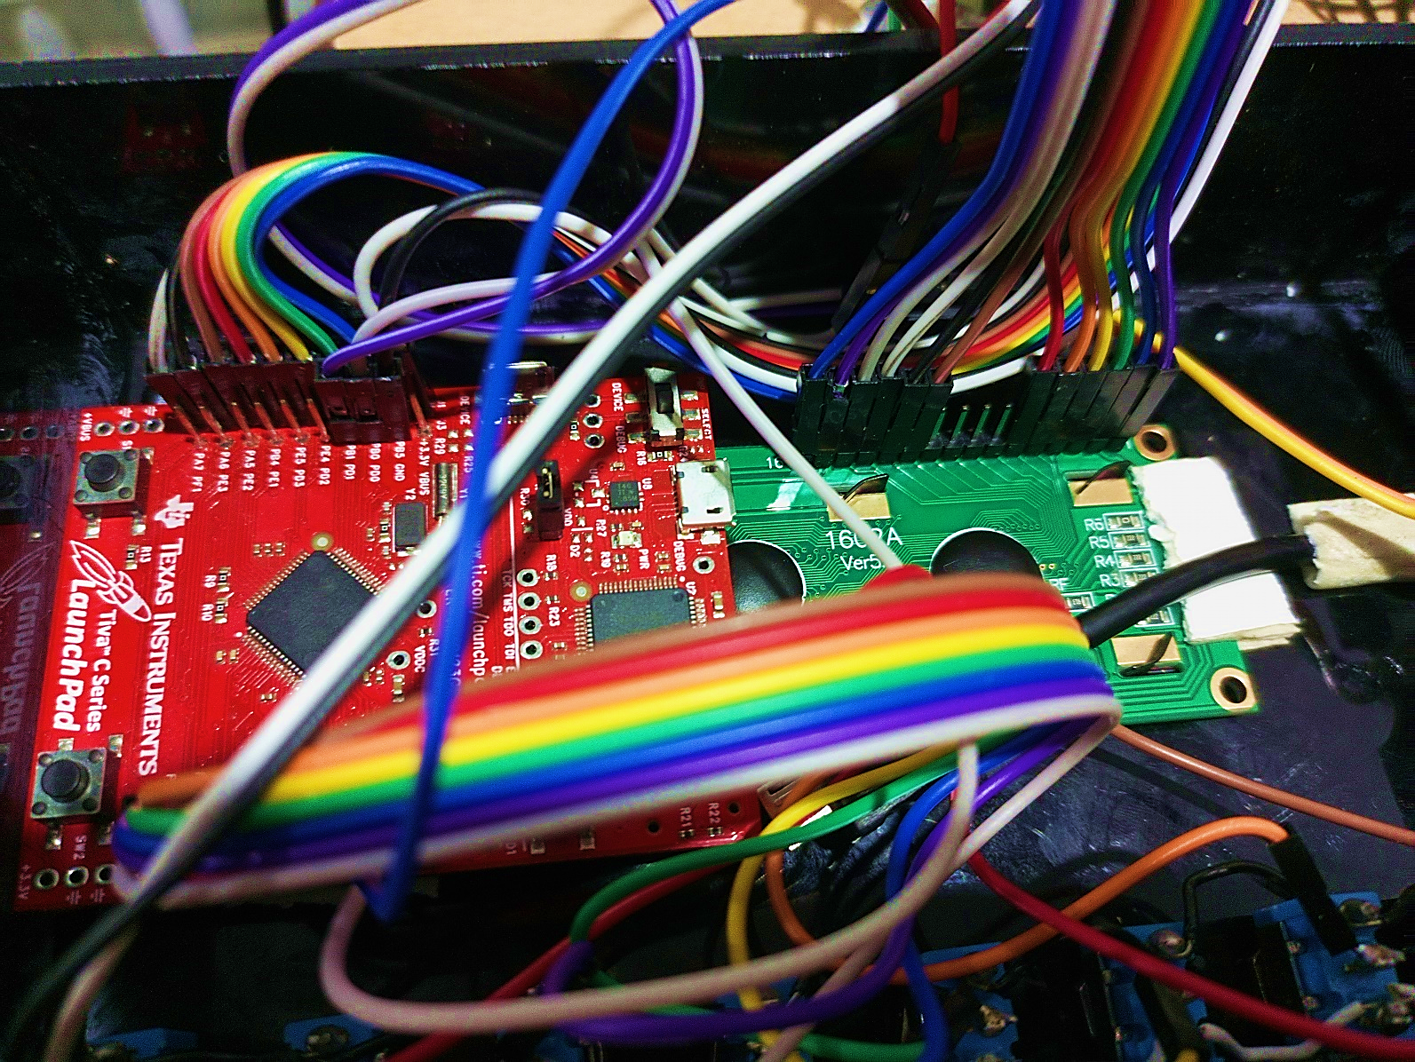

**Toggle Switches**

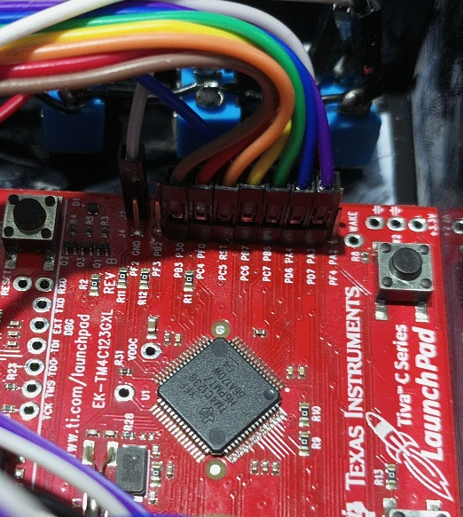

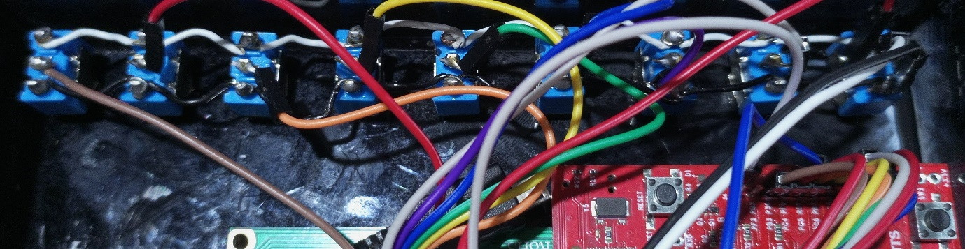

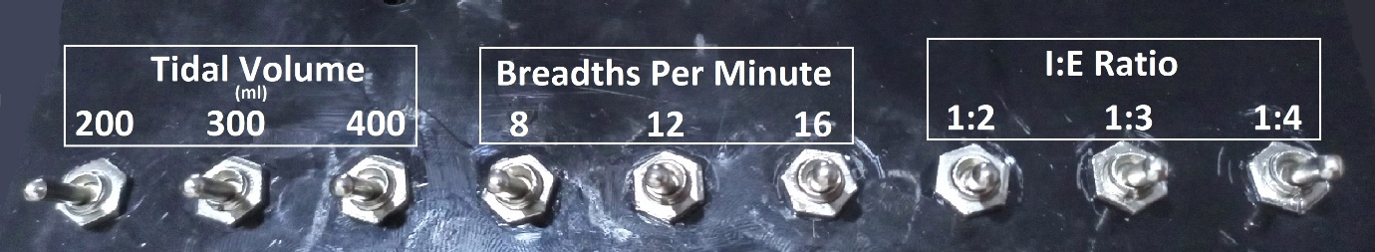

# Complete Project

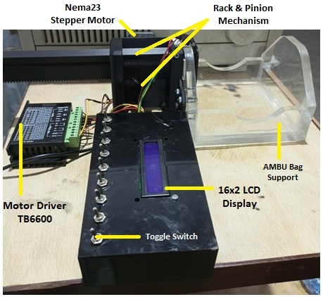

# Working Project GIF



# Bill of Materials

|  |  |  |  |  |  |
| --- | --- | --- | --- | --- | --- |
| **Sr. #** | **Item** | **Quantity** | **Price Per Unit (Rupees)** | **Total Price of Units (Rupees)** | **Vendor** |
| 1 | TM4C123GH6PM Launchpad | 1 | 7000 | 7000 | <https://hallroad.org/products/tm4c123gxl-tm4c123g-launchpad-evaluation-kit-in-pakistan-en?_pos=1&_sid=1cff50c03&_ss=r> |
| 2 | Nema23 Stepper Motor 3A | 1 | 2800 | 2800 | Zain Ali Motors (+92 321 7969026) |
| 3 | Stepper Motor Driver TB6600 | 1 | 1400 | 1400 | <https://hallroad.org/products/tb6600-stepper-motor-driver-in-pakistan?_pos=1&_sid=c78c62895&_ss=r> |
| 4 | Power Supply | 1 | 750 | 750 | <https://hallroad.org/products/12v-5a-60w-power-supply-ac-to-dc-adapter?_pos=6&_sid=6928e8576&_ss=r> |
| 5 | Limit Switch | 1 | 60 | 60 | <https://epro.pk/product/micro-tact-limit-switch-lever-arm-push-button-switch-toggle/> |
| 6 | Jumper Wires | 2 | 160 | 320 | <https://epro.pk/product/female-to-female-jumper-wires-30cm-40-pin-in-pakistan/> |
| 7 | 3D Printing (Motor Mount, Pinion, Rack) | 1 | 4200 | 4200 | <https://waleedqayyum026.wixsite.com/productdesigner/rapid-prototyping> |
| 8 | Acrylic Box (Bag Support) | 1 | 2200 | 2200 | Al Raheem Plastic (+92 340 4544658) |
| 9 | 16x2 LCD Display | 1 | 470 | 470 | <https://epro.pk/product/lcd-16x2-blue-color/> |
| 10 | Bolt & Nut M4x20 | 13 | 15 | 195 | Shop no: 305 Bazar Al-Hadeed Lahore، Punjab Lahore, 54000, Pakistan |
| 11 | Toggle Switches | 11 | 55 | 605 | <https://hallroad.org/products/toggle-switch-spdt-on-off-in-pakistan?_pos=6&_sid=677a58c9d&_ss=r> |
|  | **Total** | **34** | **19110** | **20000** |  |